Multimedia Assessed Project

(Web page development) Report

198735

**MComp Computer Science (with an industrial placement year)**

**Submitted -**

# Contents

## Introduction

### 1.1 Introduction to project

### 1.2 Introduction to report

### 1.3 Project objectives

## 2.0 Design and Development

### Website Design and Development

### 2.2 Animation Design and development

# Introduction

## Introduction to the project

This project consists of designing and building a website from scratch. The specification says that the website must have 5 pages; a homepage (which contains introductory material), a video greeting page (which contains a video clip introducing the site), a hobbies page (which contains a description of hobbies), a coursework page (which contains this report, the work from labs 3 part 3 and any other coursework relevant to this project), and finally a vector animation page with sound using JavaScript. The next section describes this document in further detail.

## Introduction to the report

This report entails the work that was done to complete the webpage development project. The report is for the module; Introduction to Multimedia. The report outlines the design and the development of the website, and the design and development for the animation on the website. The report also includes a conclusion that sums up the project, and the references used in my project. To outline goals and show the project completed these goals in the conclusion, the next section is the project objectives.

## Project objectives

### Website objectives

* + - 1. A 5-page website with the correct content on each page
      2. Well laid out site with suitable navigation bar
      3. The navigation bar stays at the top of the page
      4. A name for the site on the navigation bar and in title of webpage
      5. A text introduction on the homepage
      6. An image on the homepage
      7. An embed video clip that is less than 10 secs on the second page
      8. A description of hobbies with relevant pictures on hobbies page
      9. The project is embedded into the website on the coursework page
      10. The lab work is embedded into the website on the coursework page
      11. Coursework from recent labs is embed into the website on the coursework page
      12. A discord server plugin that allows you to see the website’s discord server on the website

### Animation objectives

[ space for the objectives when the lab on animation is completed and I get ideas]

# Design and Development

## Website Design and Development

### The Home Page

Here is the home page after the first day of development of the website.

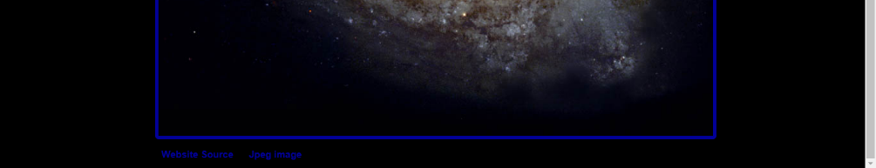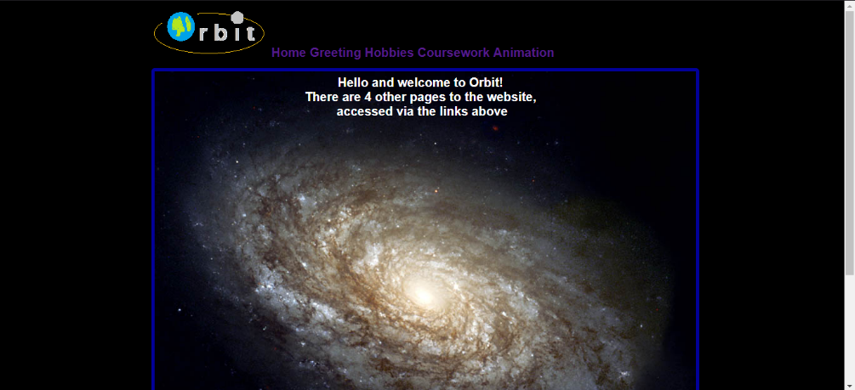As you may notice the website goes off the page (hence the scroll bar), the header now does not scroll with the page, but this should be implemented in the next stage of development. The header includes the Orbit logo, made in the Windows Paint application, 5 links to the other webpages (including this one). The free use image sits in the middle of the site with the text on top of the image. This was done because the image is so large that it takes up most of the page. In the footer, there are two links to the sources of the image, the site and the image itself.

### Links to other pages

Implemented the links to the other pages on the website seen above next to the Orbit logo. They now go to different html pages, as needed to in the specification. The Header doesn’t scroll with the page still, but this is not on the priority list for the moment.

### 2.1.3 The Video Page

Video added to the page, using HTML5, see below. Video looks good but may need some tweaking to sound good as the voice now is a bit dreary. The page has also been shortened so that you don’t have to scroll, as this made no sense with the video.

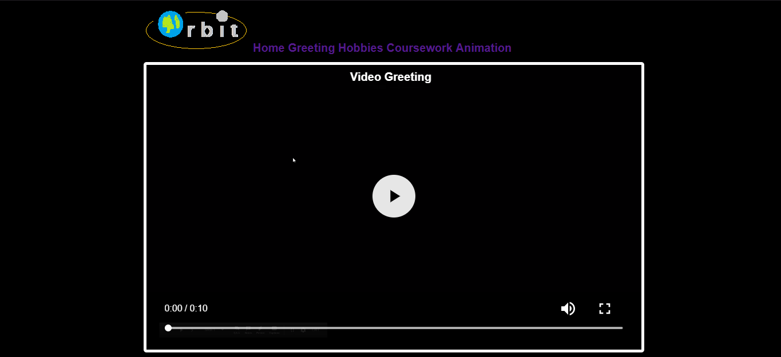

### 2.1.4 The reshuffle

Decided against putting each section on a different html page, as this was messy and lead to unnecessary code. Reading the Coursework FAQ also swayed the decision. The Animation shall be on a different page however, as this will be different to the rest of the website. The links at the top of the page now link to the corresponding header instead of another html document.

Added some borders to the different sections for them to be identifiable. Also added the scrollable header. This needs some work though as it doesn’t work correctly when a link has been clicked. E.g.

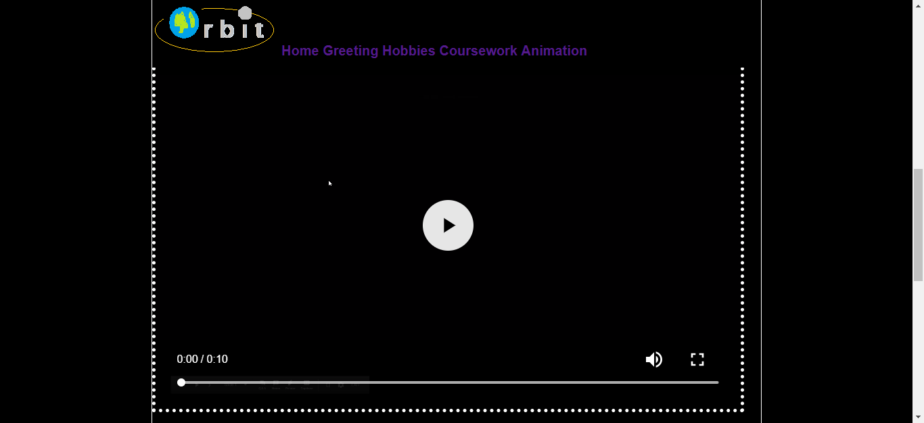

## Animation Design and development